Dashboarding

Explore the benefits of using interactive data applications to improve business performance.

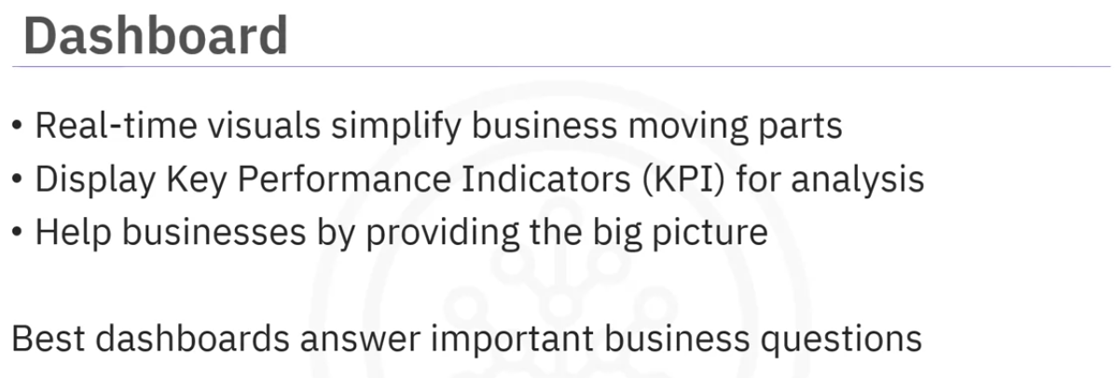

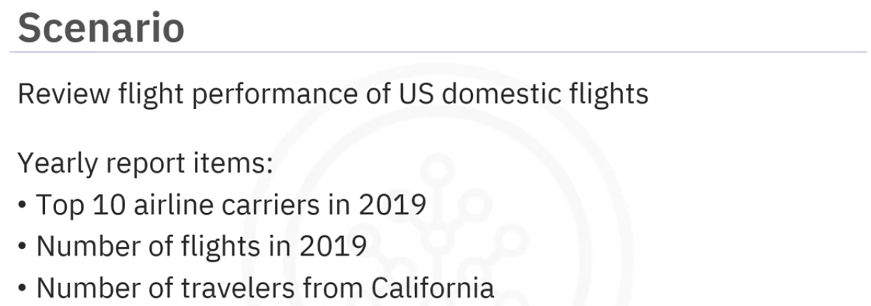

Lets see 2 ways of presenting the report for the scenario above.

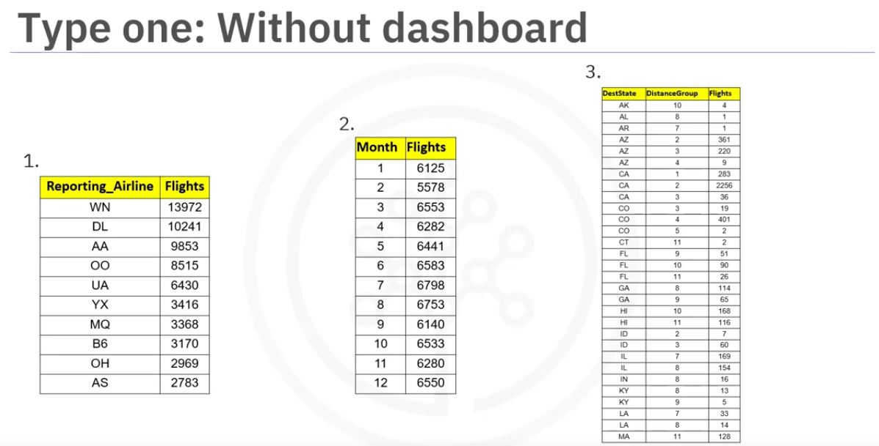

Type 1 is to provide tables that documents inferences.

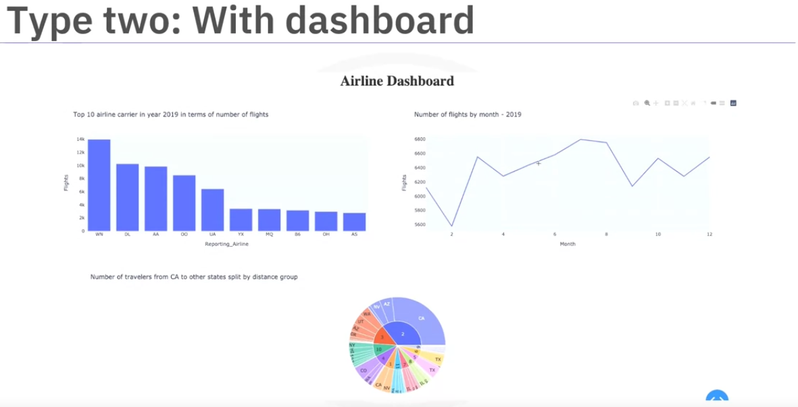

Type 2 is to use dashboards. We can iteract with it to get more info. I can be used get reports on real time data instead of static data.

The following are web based python dashboarding libraries.

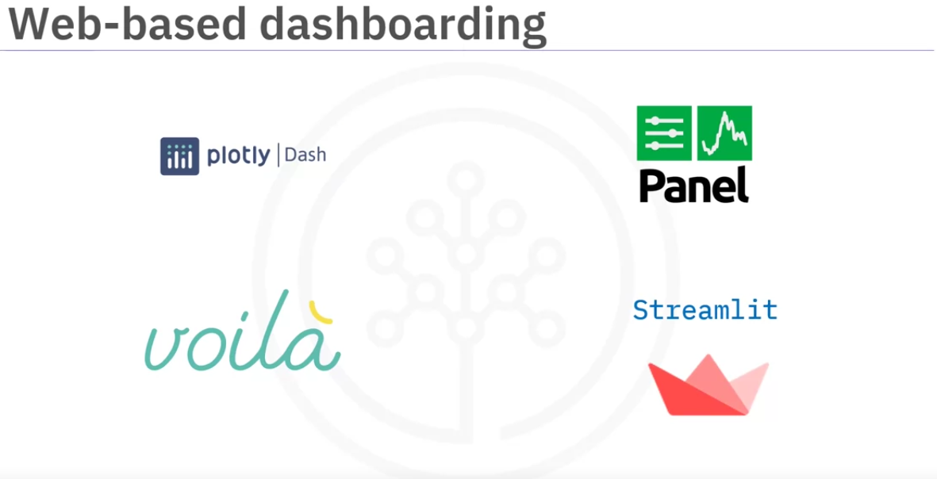

Dash is a python framework that is used to building analytics applications.

It run on top of flash, plotly.js and react.js. Used to build interactive apps with highly customizable interfaces.

panel works with visualization that works with bokeh, Matplotlib, holoview and many other python plotting libraries, making them view individually or combined with interactive widgets that control them. Panel works equally good in jupyter notebooks for creating quick data exploration tools or as standalone deployed app in dashboards and allows you to easily switch between those contexts as needed.

voila turns jupyter notebooks into standalone applications. It is compatiple with seperate layout tools like jupyter-flex or templates like voila-vuetify.

Streamlit can easily turn data scripts into shareable web apps with three main principles.

1. embrace python scripting
2. treat widgets as variables.
3. Reuse data and computation.

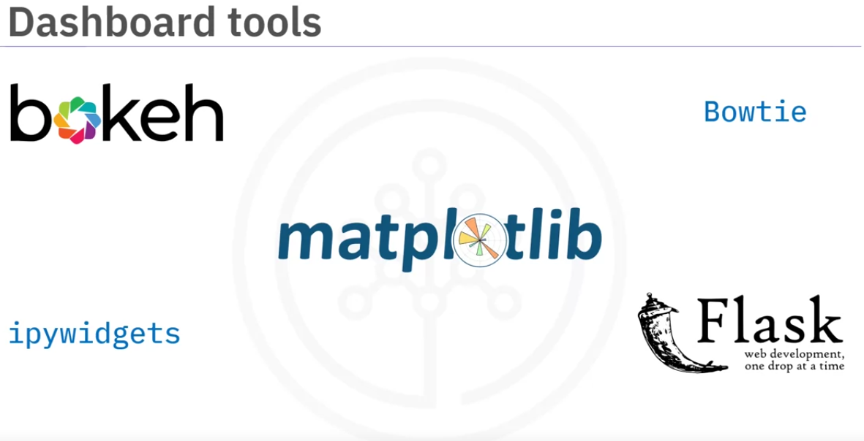

There are other tools that can be used for bashboarding.

Bokeh is a plotting library, widget, and app library. It acts like server for both plots and dashboards. Panel, which is one of the web-based dashboarding tools, is built on bokeh.

ipywidgets provide a wide variety of jupyter widgets , an interface supported by many python libraries. But sharing as a dashboard requres a seperate deployable server like voila.

Matplotlib is a comprehensive library to create static, animated and interactive visualizations in python.

Bowtie allows users to build dashboards in pure python.

Flask is a python backend server that builds arbitraty websites, including those with python plots that then function as Flask dashboards.

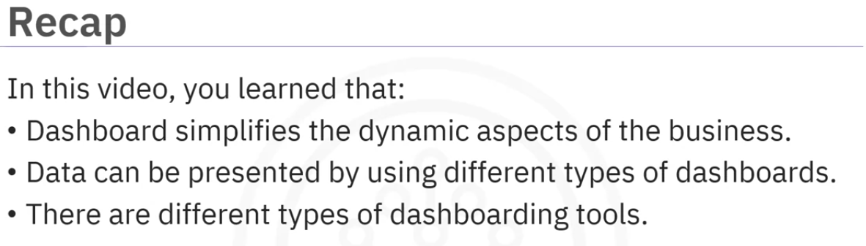

More tools:

<https://pyviz.org/dashboarding/>

<https://www.theguardian.com/news/datablog/2013/mar/15/john-snow-cholera-map>

Plotly

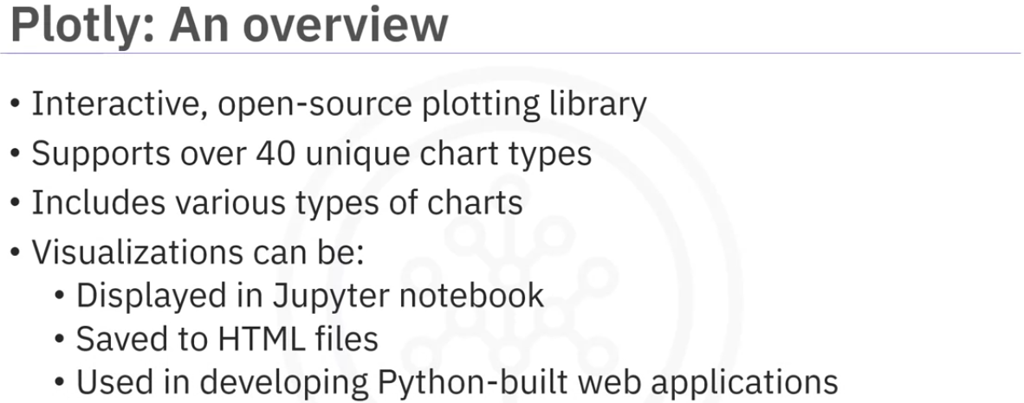

Available in python, R, js. plotly python is an extension of plotly js.

Contains chart types like statistical, financial, maps, scientific and tree-dimentional data.

Web based.

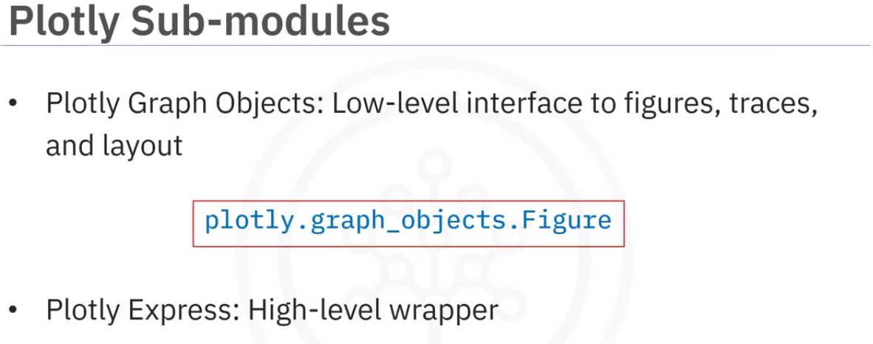

plotly graph objects provides automatically generated hierarchy to classes, figures, traces, and layout called graph objects that are used to representing figures with top level class Plotly.graph\_objects.Figure.

Plotly Express is a high level wrapper for Plotly. It is recommend for creating most common figures provided by plotly because of its simple syntax. It uses graph objects internally.

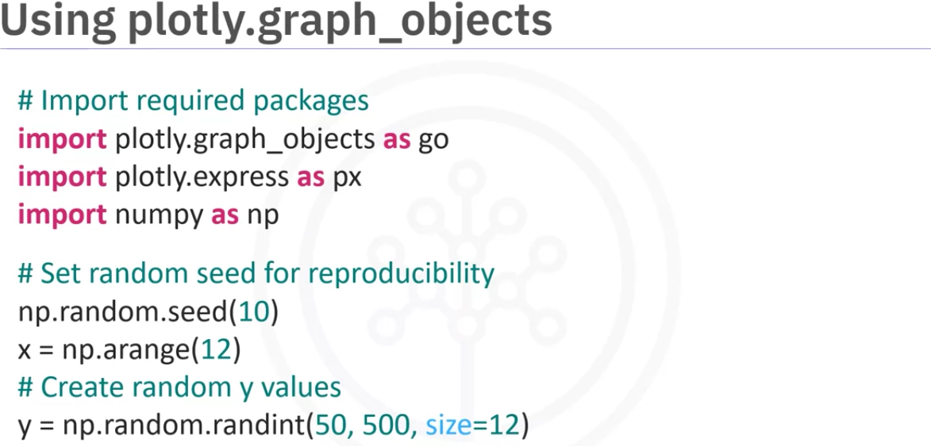

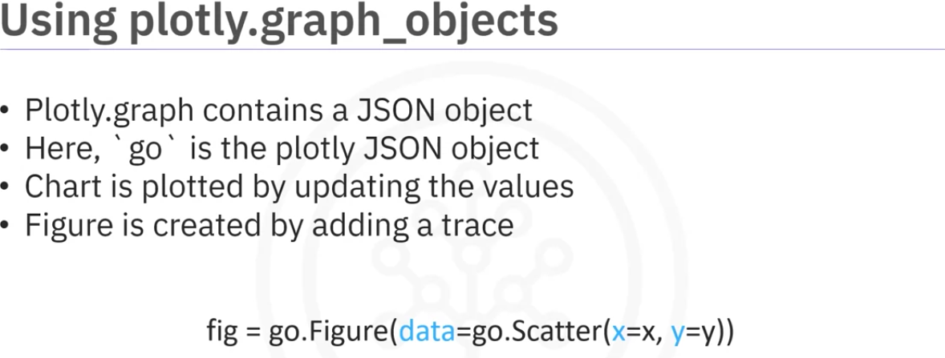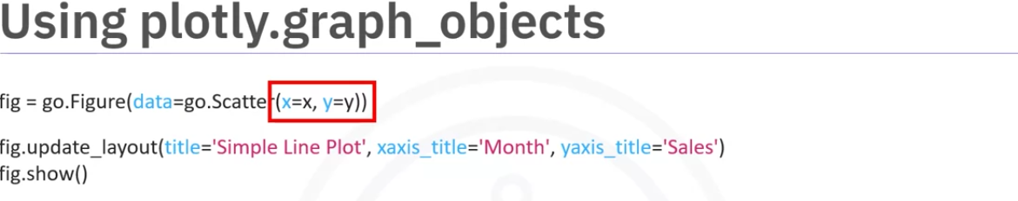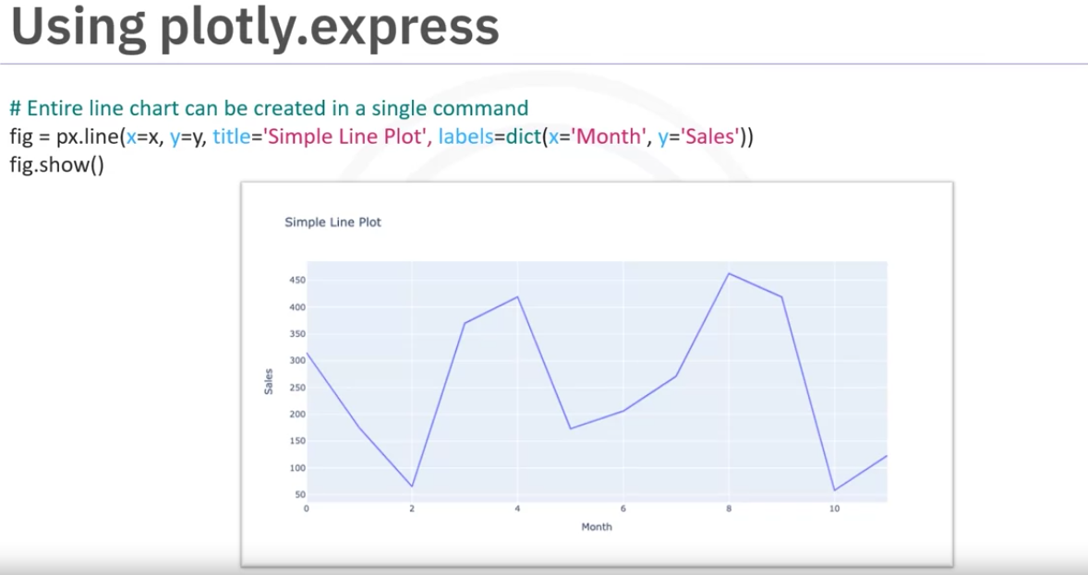

As we can see above uisng graph objects involves multiple steps compared to plotly express.

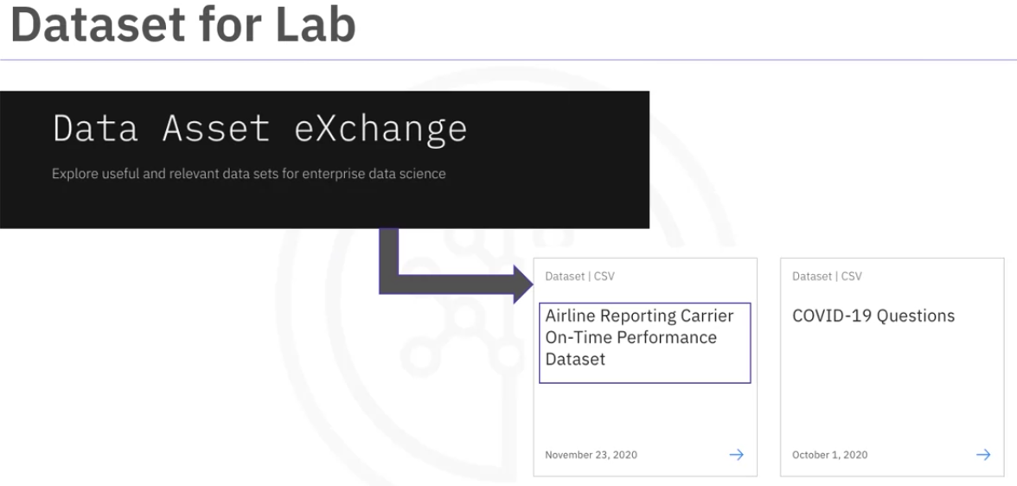

We will use the above dataset from Data Asset exchange to work with plotly in the lab to create different plots.

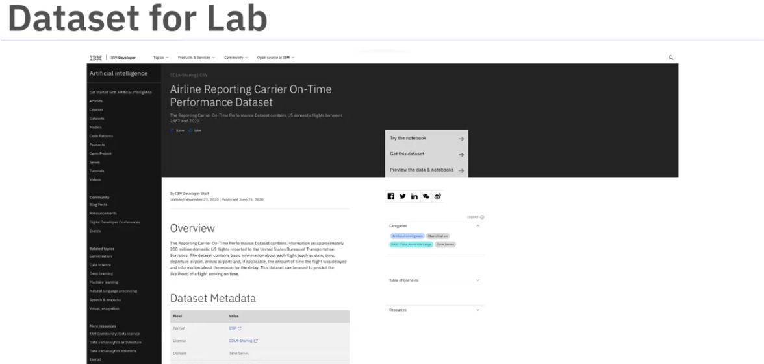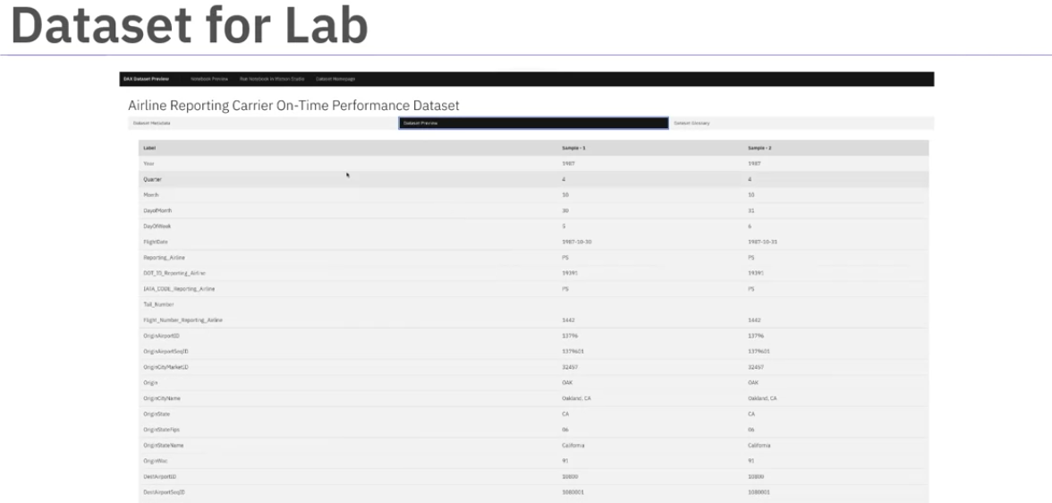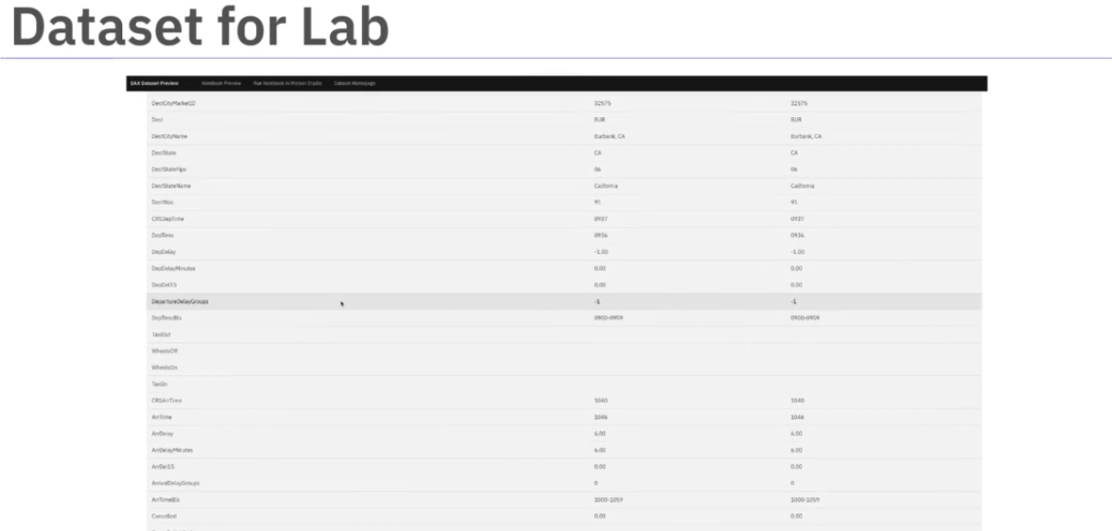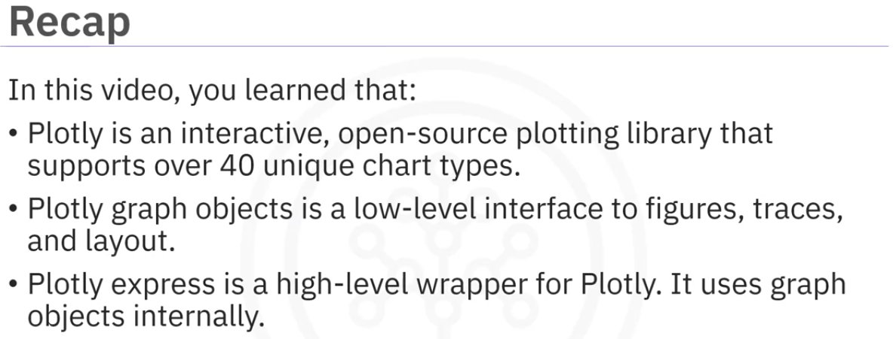

More resources on plotly:

<https://plotly.com/python/getting-started/>

<https://plotly.com/python/graph-objects/>

<https://plotly.com/python/plotly-express/>

<https://plotly.com/python-api-reference/>

<https://images.plot.ly/plotly-documentation/images/plotly_js_cheat_sheet.pdf>

<https://community.plotly.com/c/plotly-python/5>

<https://plotlygraphs.medium.com/>

<https://developer.ibm.com/exchanges/data/>

Dash Basics

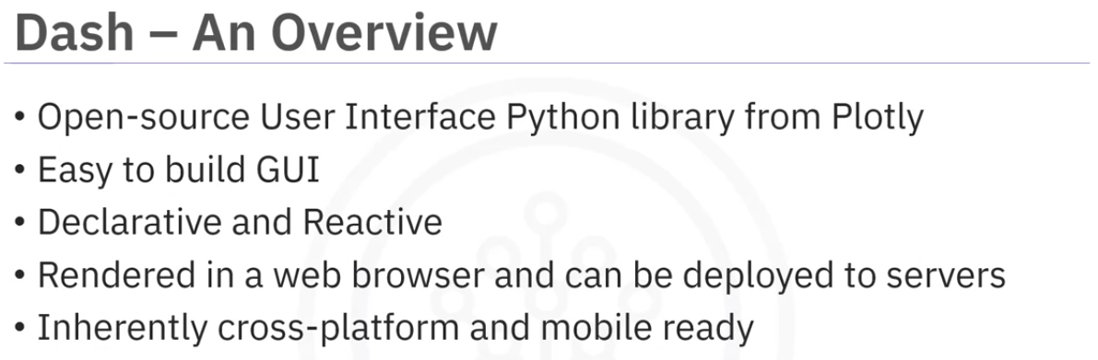

Used to create Reactive web based applications.

Both enterprise-ready and a first class member of plotly’s open-source tools.

Dash appplications are servers running on flask communicating JSON packets over HTTP requests.

Dash’s front end renders components using React.js.

Its easy to build GUI using Dash as it is abstracts away all technologies required to make the applications.

It is delacartive and Reactives. I can be rendered on a browser or deploted to a server.

it provides imple reactive decorator for binding code to UI.

They are inherently mobile and cross platform ready.

Lets say you plan to create an application to answer business questions. As a first step, you need to determine the application’s layout. decide which plot to use and where to place it.

This is called the layout part of dash

the second part is to add interactivity to the application.

There are 2 components of dash Core components and html components.

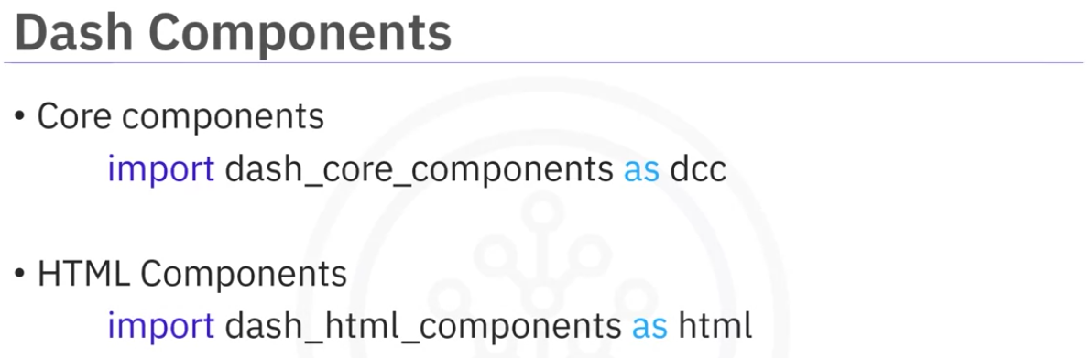

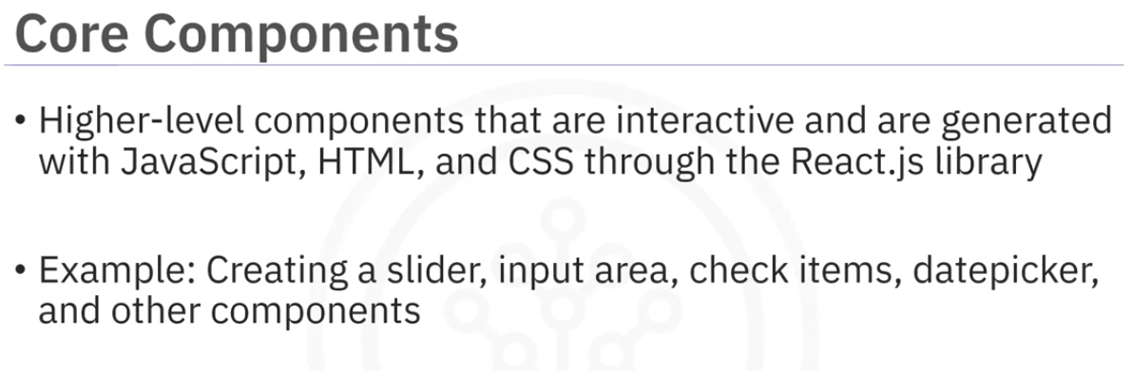

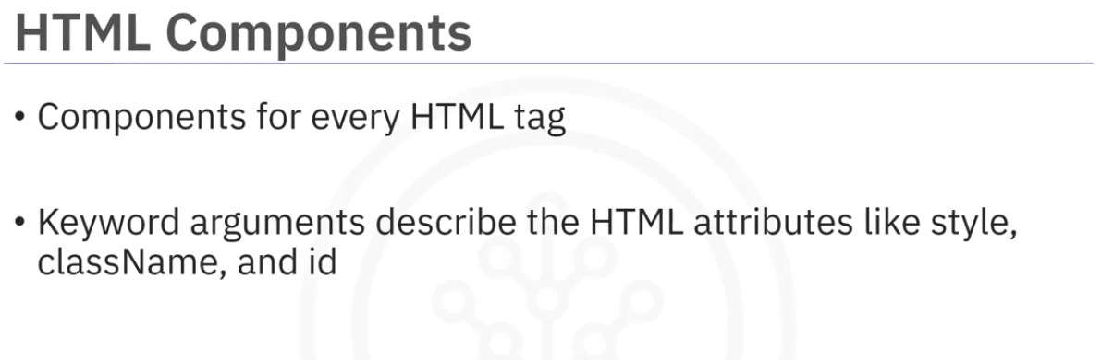

you can compose your layout using python structures with dash\_html\_components library.

It provides classes for all the html tags and keyword arguments that provide html arguments like styles, class, id and so on.

No knowledge of html or css is required but it can style the dashboards.

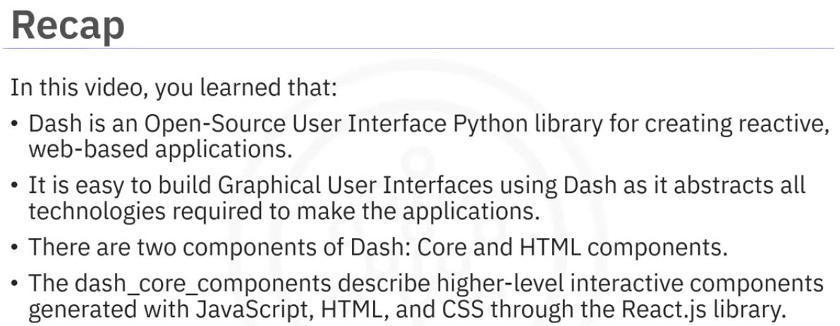

Additional Resources for Dash

To learn more about Dash, explore

[Complete dash user guide](https://dash.plotly.com/" \t "/home/vastan1993/Documents\\x/_blank)

[Dash core components](https://dash.plotly.com/dash-core-components" \t "/home/vastan1993/Documents\\x/_blank)

[Dash HTML components](https://dash.plotly.com/dash-html-components" \t "/home/vastan1993/Documents\\x/_blank)

[Dash community forum](https://community.plotly.com/c/python/25" \t "/home/vastan1993/Documents\\x/_blank)

[Related blogs](https://medium.com/plotly/tagged/dash" \t "/home/vastan1993/Documents\\x/_blank)

Make Dashboards interactive

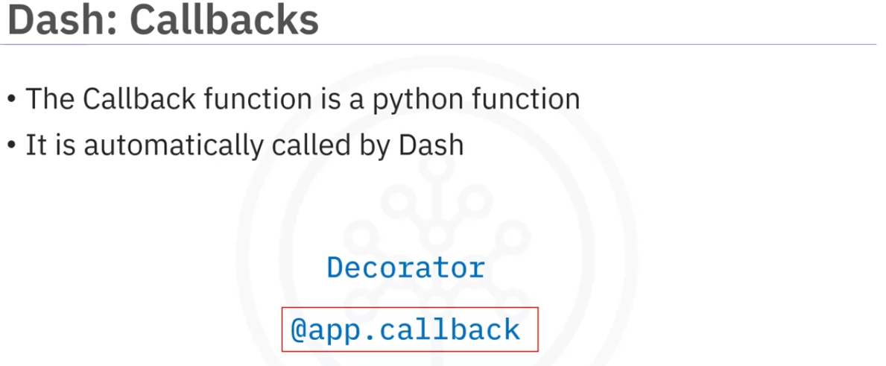

its a python function that calls that is automatically called when the input is changed,

Callback function is decorated with a decorator @app.callback.

When there is a change in the input value the function is automatically called. Then the new output is shown in the app layout.

Lets take a look at the structure of the callback function.

WE will create a function with a parameter . then we perform some task which creates a graph and returns it. Then we add the callback decorator before the function definition.

the callback contains 2 parameters. one is Output and the other is Input objects.

There can be more than 1 Input object.

The number of parameter for the function depends on the number of Input objects.

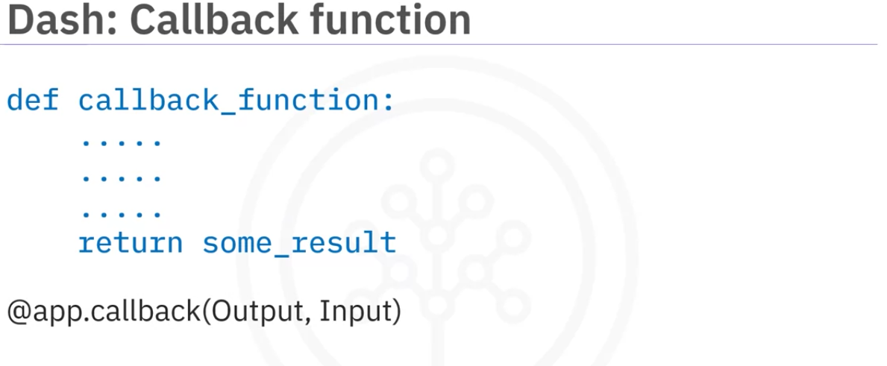

The Output object helps to set the results(a graph) onto the app layout.

The Input object on the other hand receives input from the input (html) elements.

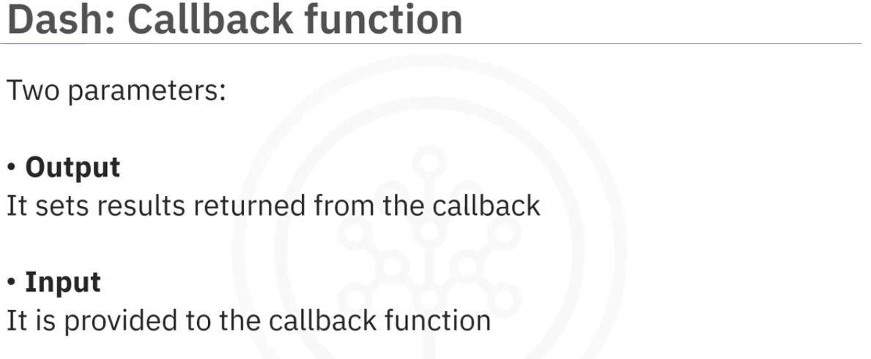

Here is an example of a program that has the callback functions.

We can see that we are inporting the Input and the Output classes from the dash.dependencies.

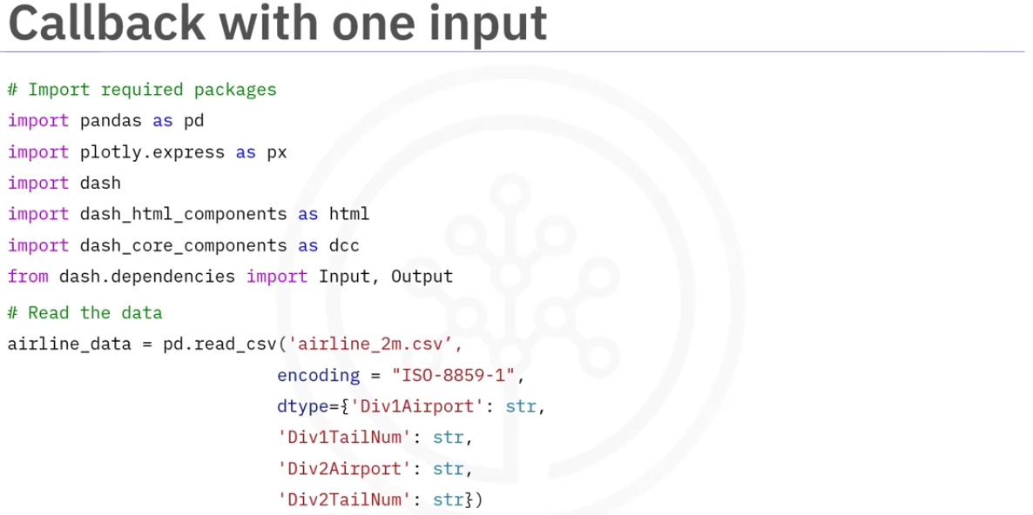

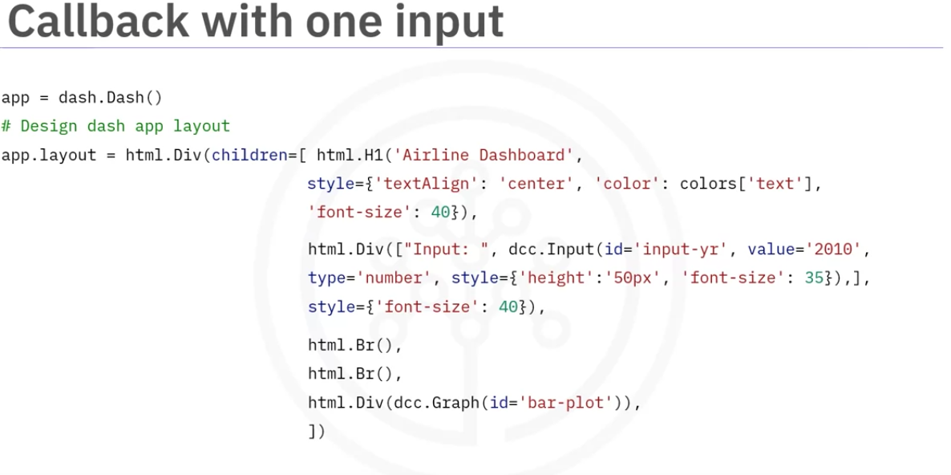

The following image shows the callback that has the decorator. The Input and the object contains 2 keyword arguments. component\_id, component\_property. These are html properties that we use when creating the layout

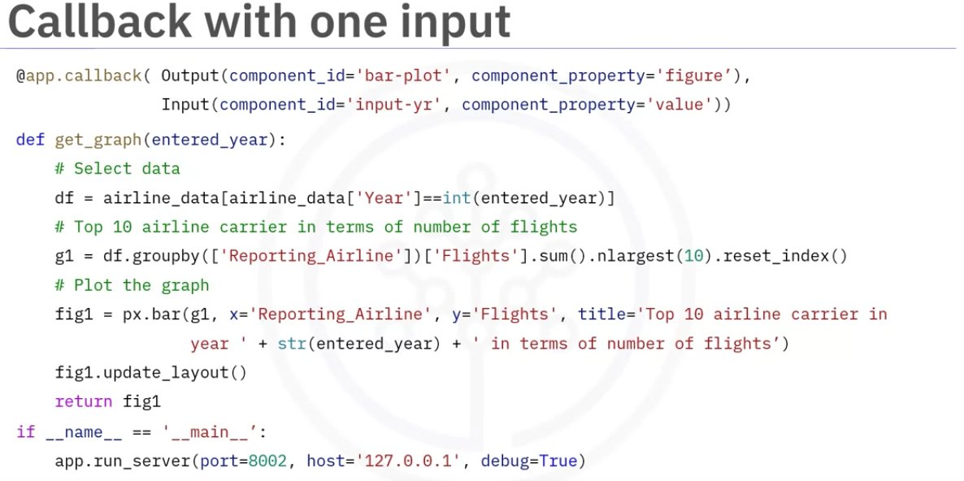

We can interact with the input and it gives us a differnt graph each time the input is updated

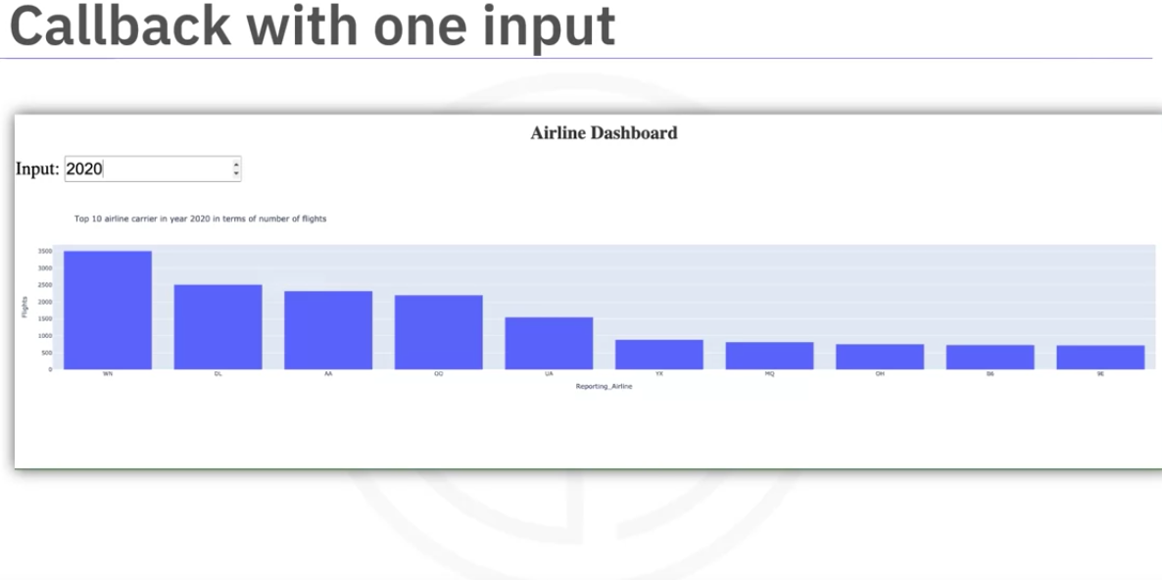

We can provide more than 1 Input object which can be used to build the graph.

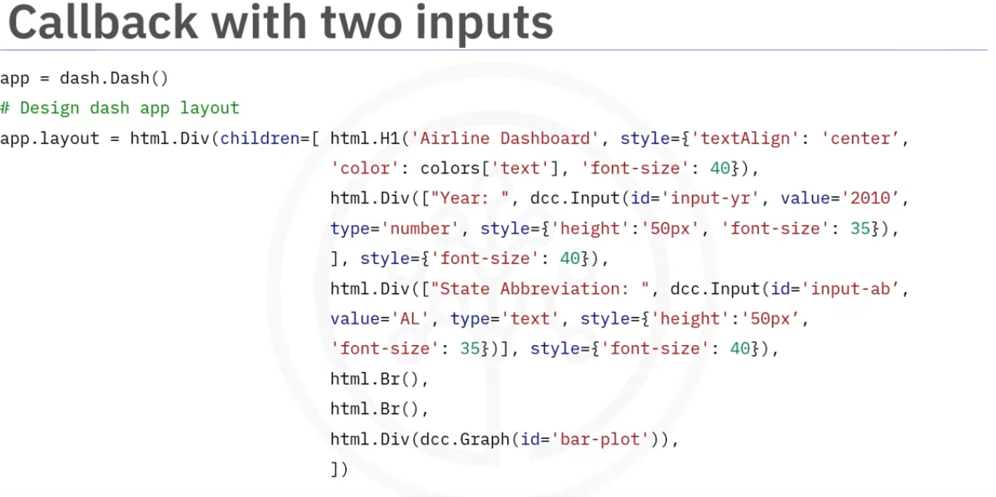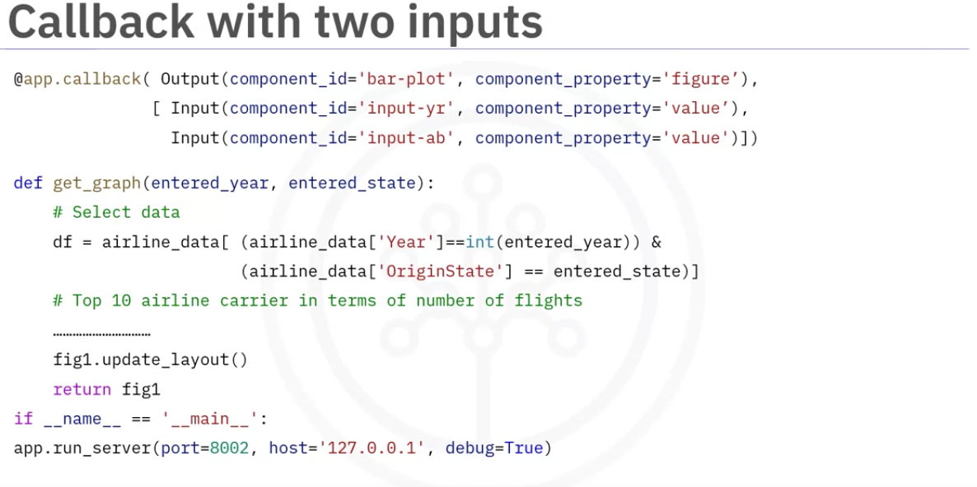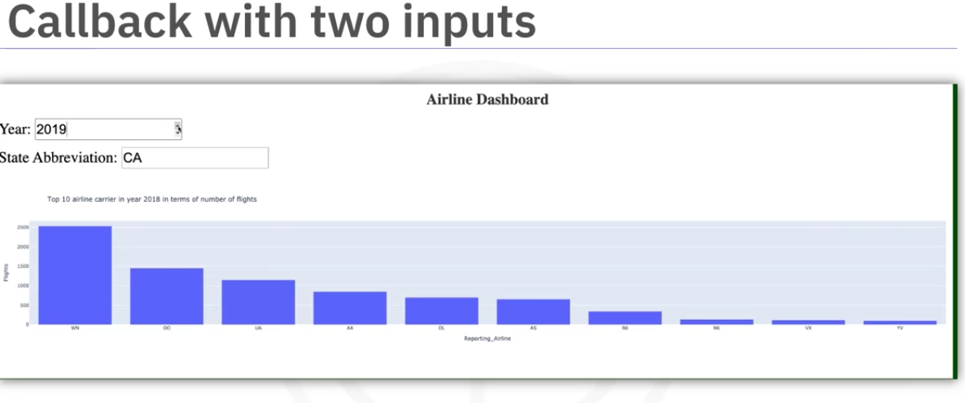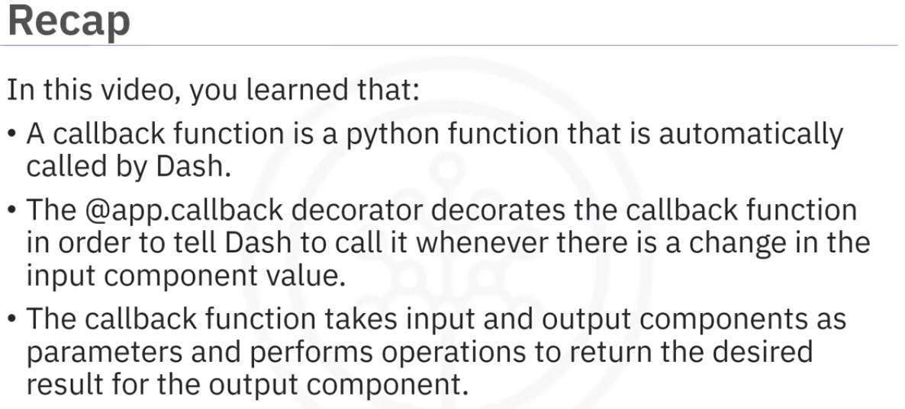

Additional Resources for Interactive Dashboards

To learn more about making interactive dashboards in Dash, visit

[Python decorators reference 1](https://realpython.com/primer-on-python-decorators/" \t "/home/vastan1993/Documents\\x/_blank)

[Python decorators reference 2](https://www.python.org/dev/peps/pep-0318/" \l "current-syntax" \t "/home/vastan1993/Documents\\x/_blank)

[Callbacks with example](https://dash.plotly.com/basic-callbacks" \t "/home/vastan1993/Documents\\x/_blank)

[Dash app gallery](https://dash-gallery.plotly.host/Portal/" \t "/home/vastan1993/Documents\\x/_blank)

[Dash community components](https://plotly.com/dash-community-components/" \t "/home/vastan1993/Documents\\x/_blank)

Lab Instrctions

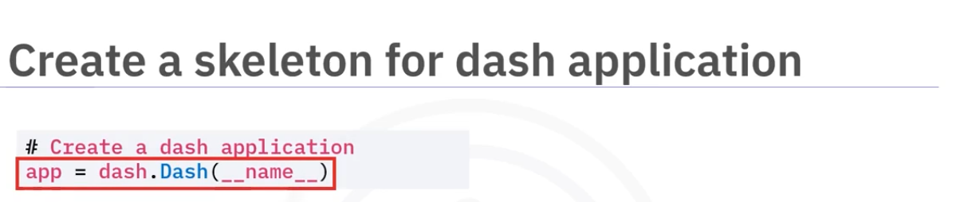

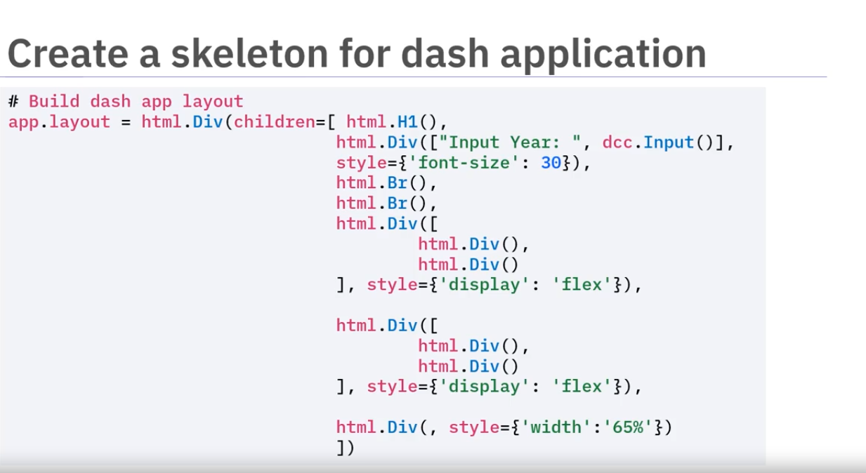

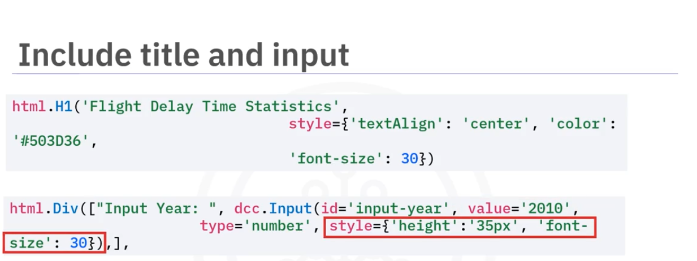

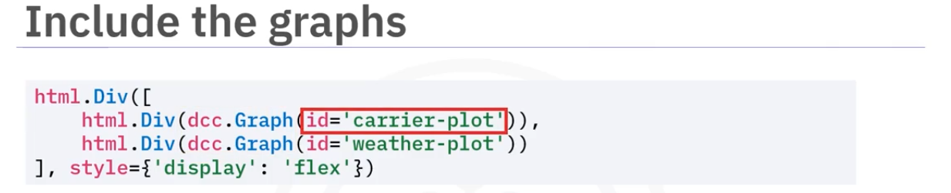

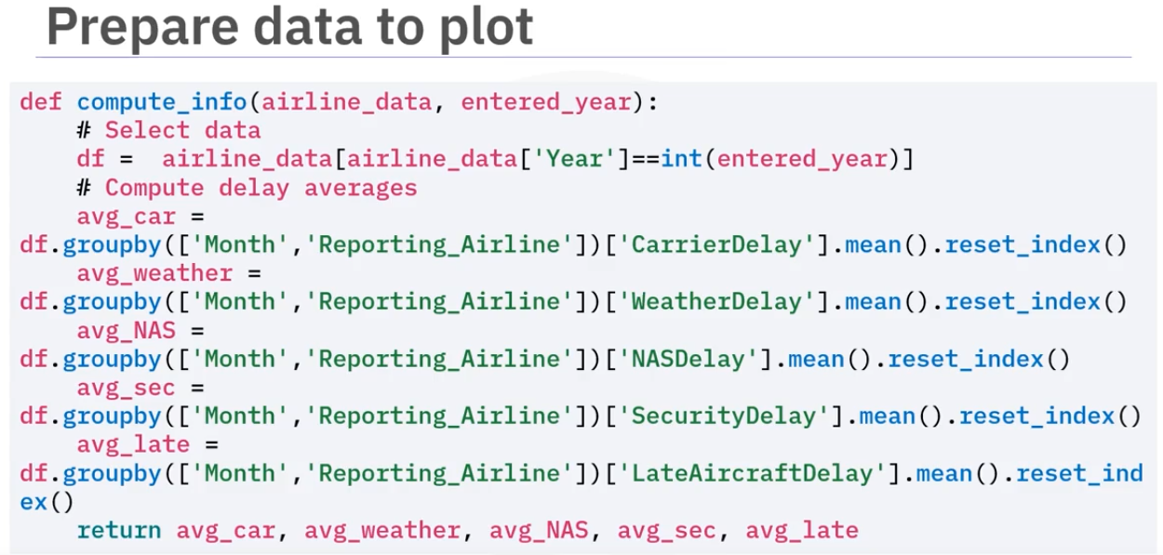

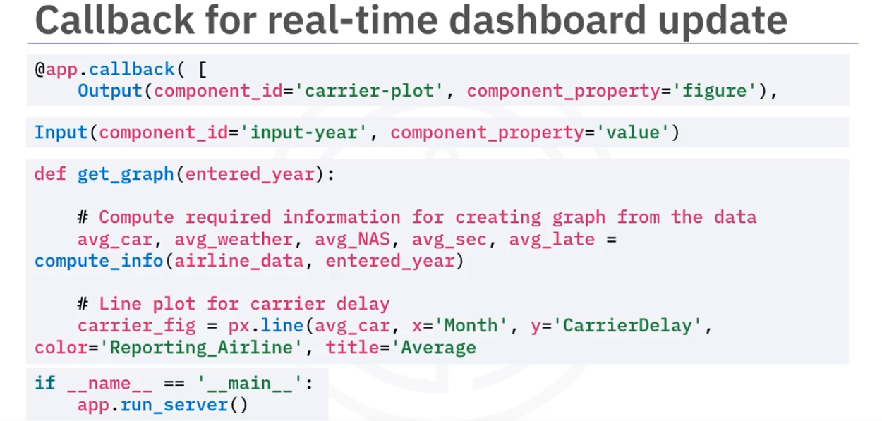

Summary: Creating Dashboards with Plotly and Dash

Congratulations! You have completed this module. At this point in the course, you know:

Dash is an Open-Source User Interface Python library for creating reactive, web-based applications.

It is easy to build Graphical User Interfaces using Dash as it abstracts all technologies required to make the applications.

There are two components of Dash: Core and HTML components.

The dash\_core\_components describe higher-level interactive components generated with JavaScript, HTML, and CSS through the React.js library.

The dash\_html\_components library has a component for every HTML tag.

A callback function is a python function that is automatically called by Dash whenever an input component's property changes.

The @app.callback decorator decorates the callback function in order to tell Dash to call it whenever there is a change in the input component value.

The callback function takes input and output components as parameters and performs operations to return the desired result for the output component.